**Audience:** Ambulatory Clinicians

This flash outlines the orders for flu vaccines:

**Flu Vaccine for ages 6months and up:**

**Influenza virus vaccine, inactivated preservative-free quadrivalent intramuscular suspension**



**Flu Vaccine for ages 65+**

**Fluzone High-Dose Quadrivalent PF 2020-2021 Intramuscular Suspension**

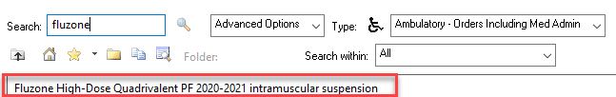

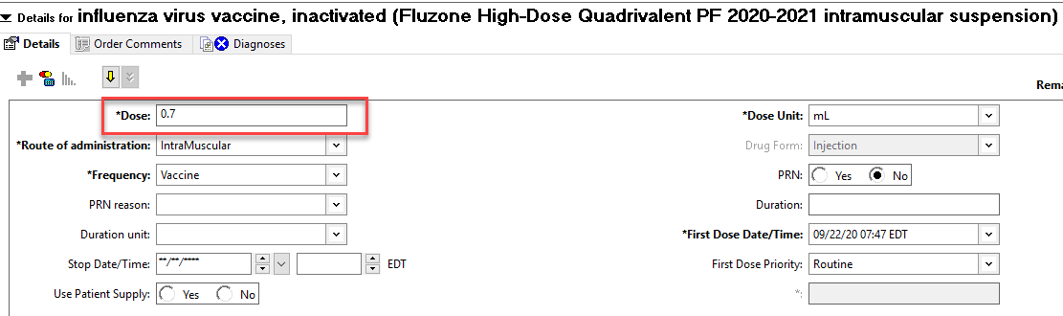

Ambulatory: 2020-2021 Flu Vaccine Orders

**09/22/2020**